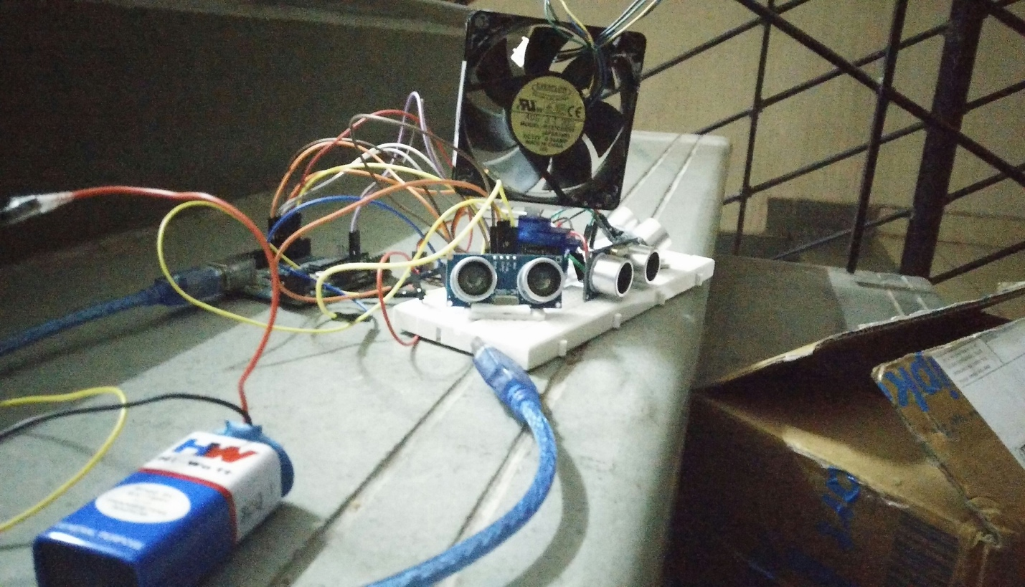

**COMPONENTS USED:-**

1. **Arduino Board**
2. **Ultra sonic Sensor-3**
3. **Servo Motor**
4. **Fan**
5. **9V Battery**
6. **Wires**
7. **Bread Board**

**CIRCUIT DIAGRAM:-**

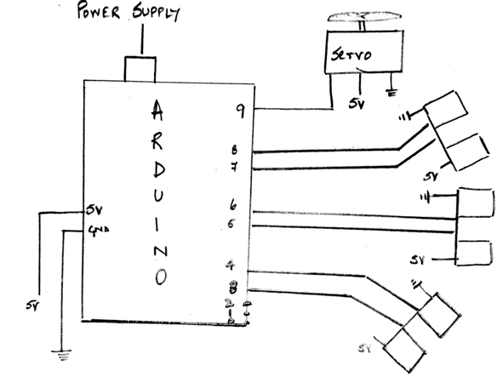

**PIN DESCRIPTION:-**

We define the pins first in the Arduino Board, Pin 3 acts as the trigger pin of sensor 1 (30 degrees) and pin 4 as the echo pin of sensor 1. Pin 5 acts as the trigger pin of sensor 2 (90 degrees) and pin 6 acts as the echo pin of sensor 2. Pin 7 acts as the trigger pin of sensor 3 (150 degrees) pin 8 acts as the echo pin of sensor 3.

**WORKING:-**

If any of the Ultrasonic sensors detect an object at less than 20cm distance in front of it the servo motor rotates the fan in that direction and it remains in that direction as long as the obstacle is not removed and the loop containing that part of the program goes on repeating. This process repeats with all the three sensors and the servo motor keeps on rotating the fan towards the sensor in front of which there is an obstacle. As soon as an obstacle is placed in front of a different sensor the servo motor rotates the fan in that particular direction.

When obstacles are placed in front of two Ultrasonic sensors the fan covers the area in front of both those sensors. Example:- When we place an obstacle between sensor 1 (30 degrees) and sensor 2 (90 degrees) the fan rotates continuously 30 degree and 90 degree. When we place an obstacle between sensor 2 (90 degrees) and sensor 3 (150 degrees) the fan rotates continuously 90 degree and 150 degree. When we place an obstacle between sensor 1 (30 degrees) and sensor 3 (150 degrees) the fan rotates continuously 30 degree and 150 degree.